

Instalacion Xampp en linux

Aplicaciones Web



21 de febrero de 2025

Marco reguero acebes

1ºSmr

INDICE

1-Instalacion de Ubuntu____________________________Pg. 2

1.1-Instalar Ubuntu________________________________________________Pg.2

1.2-Actualizar el sistema____________________________________________Pg.3

2-Instalacion de Xampp____________________________Pg. 4

2.1-Descargar Xampp_____________________________________________Pg. 4

2.2- Instalar Xampp_______________________________________________Pg. 5

2.3-Instalacion finalizada___________________________________________Pg. 5

3-Instalacion de Wordpress_________________________Pg. 6

3.1-Descargar Wordpress___________________________________________Pg. 6

1-Instalacion de ubuntu

1.1-Instalar Linux

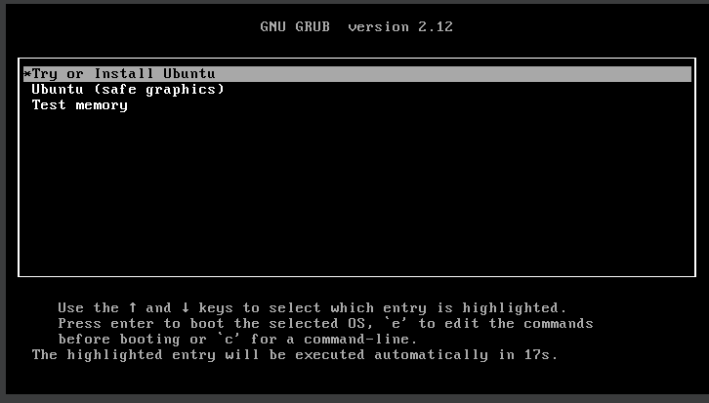

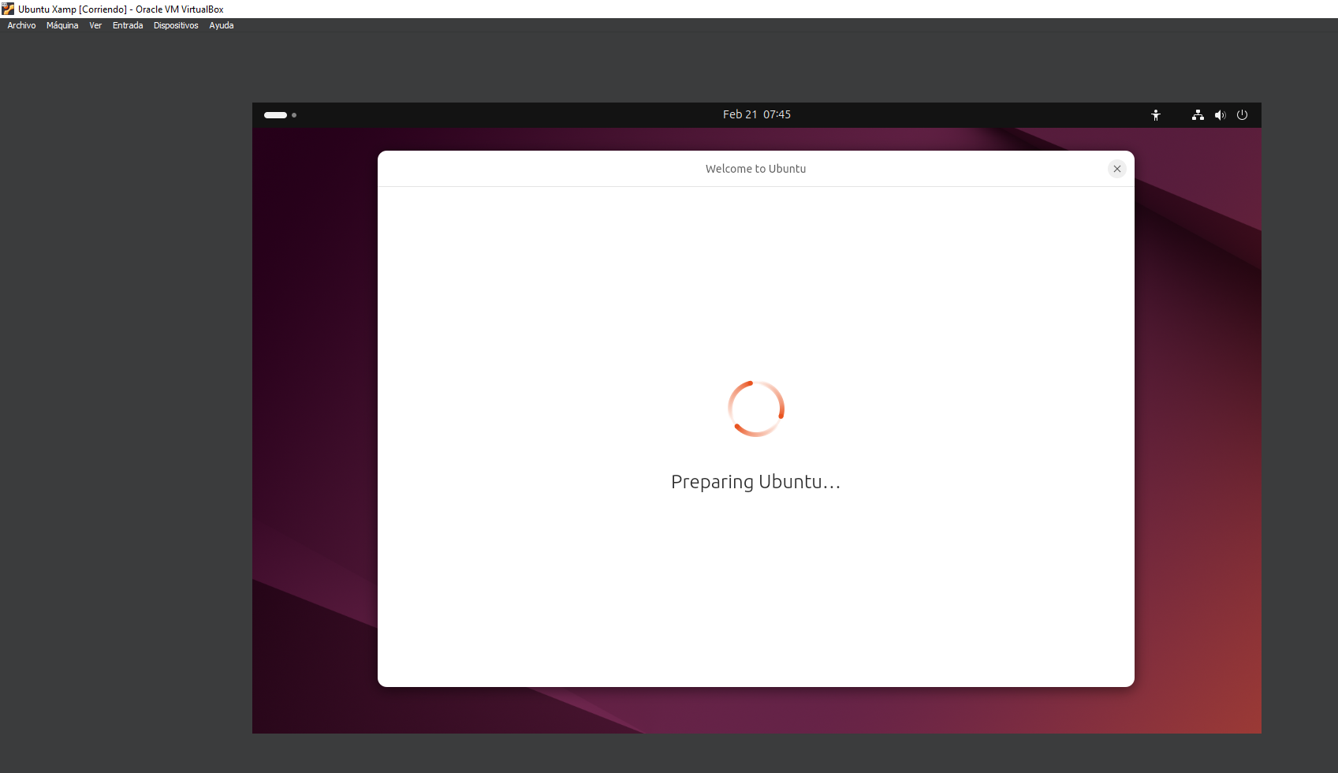

1.2-Actualizar el sistema

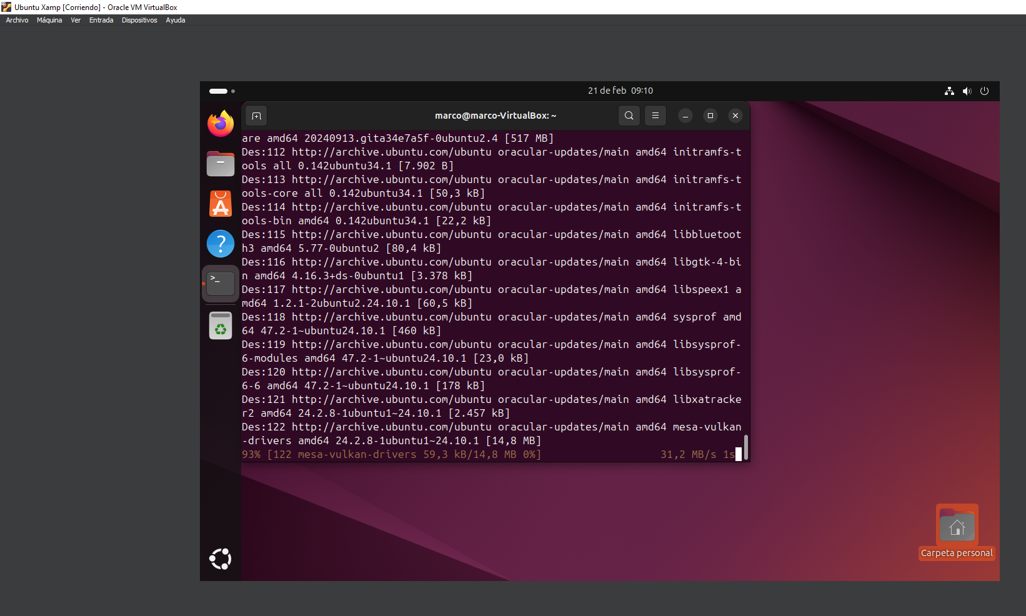

2-Instalacion de xampp

2.1-Descargar Xampp

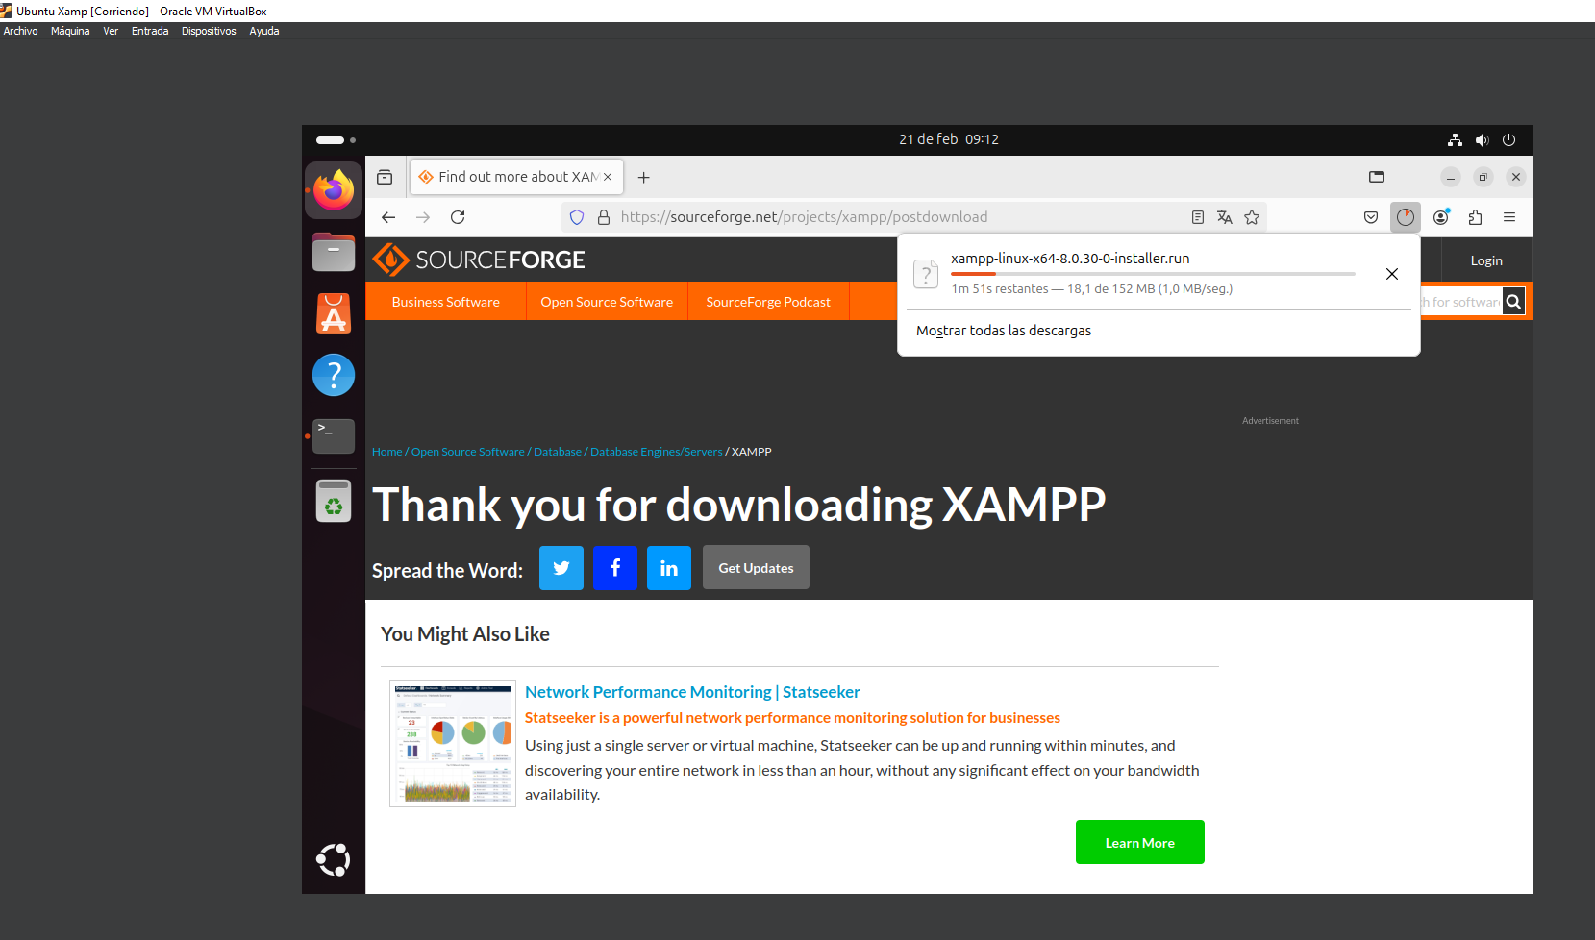

2.2-Instalo Xampp

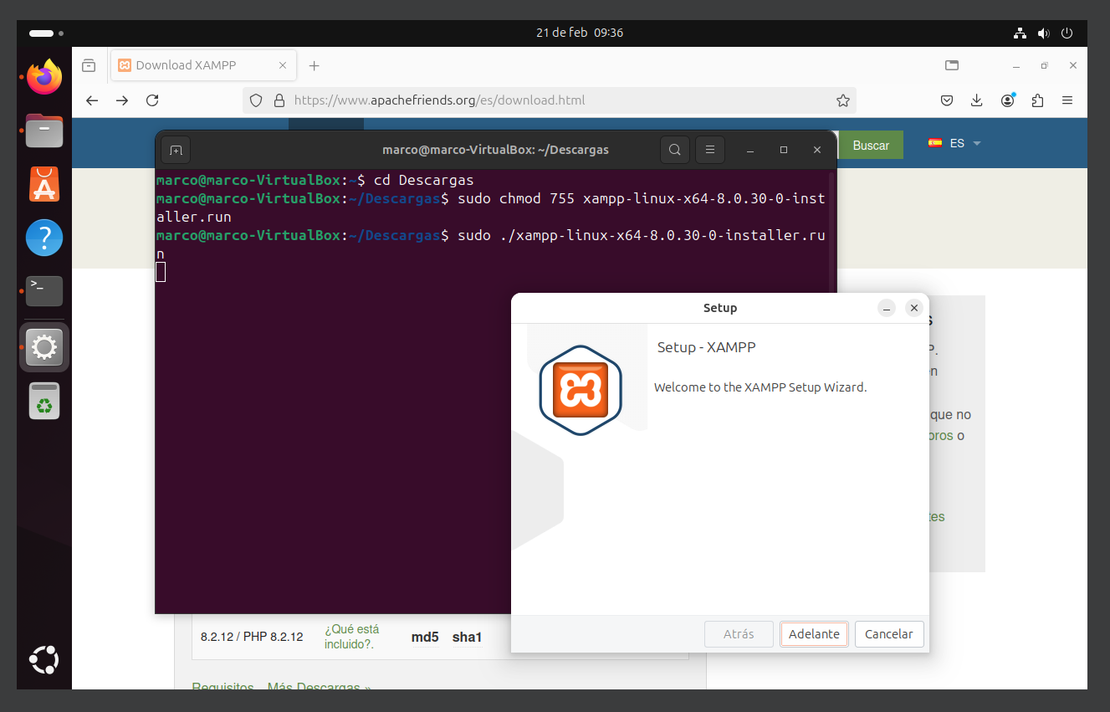

2.3-Instalacion finalizada

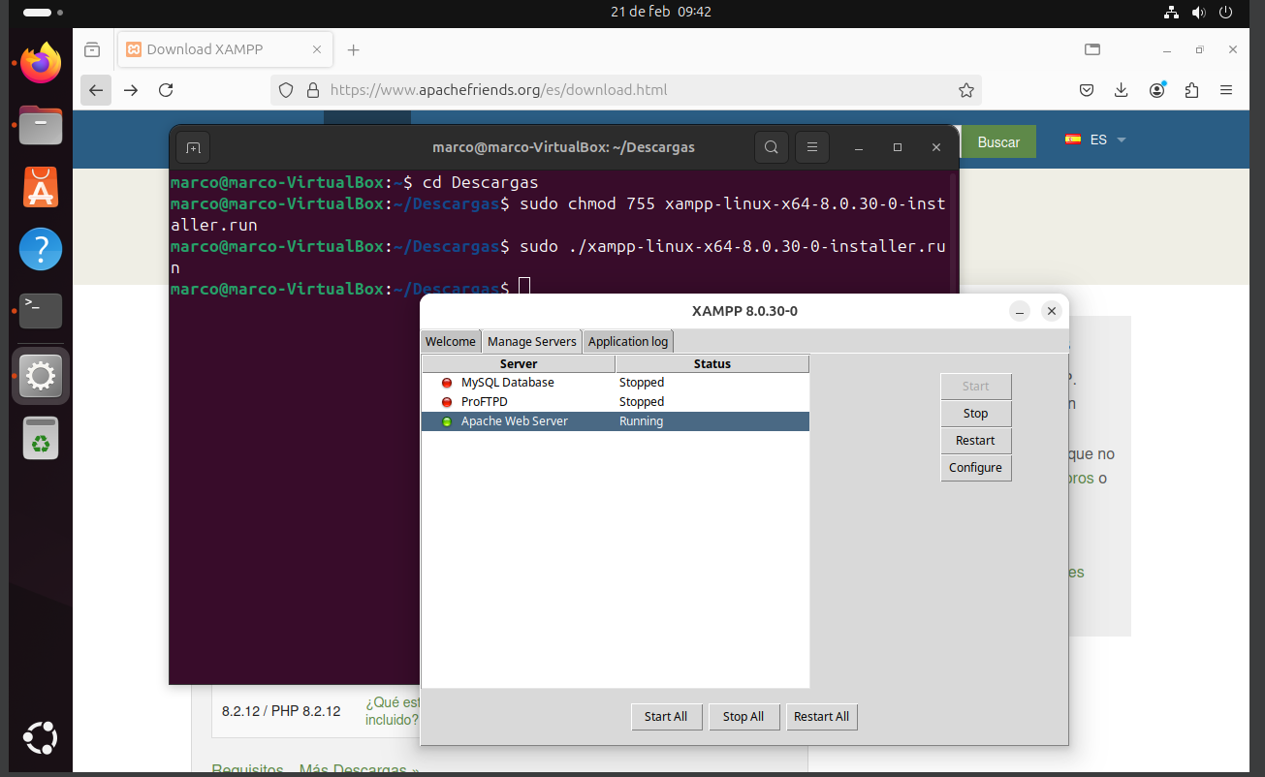

3-Instalacion de WordPress

3.1-Descargar Wordpress

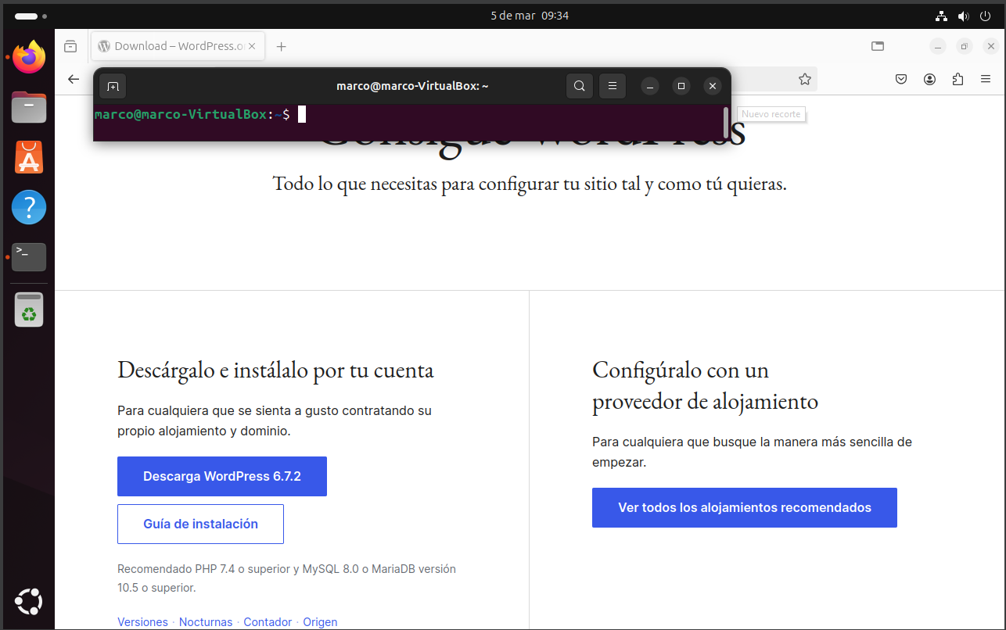

3.2-Instalar Wordpress